AWS: CREATE S3 BUCKET

STEP 1: Creating S3 bucket named **my-assessment-bucket-1.**

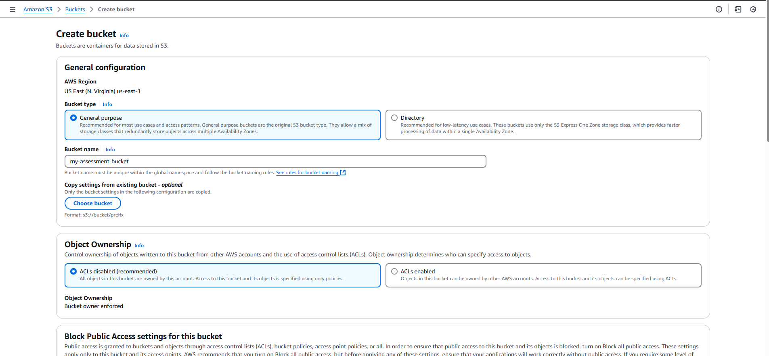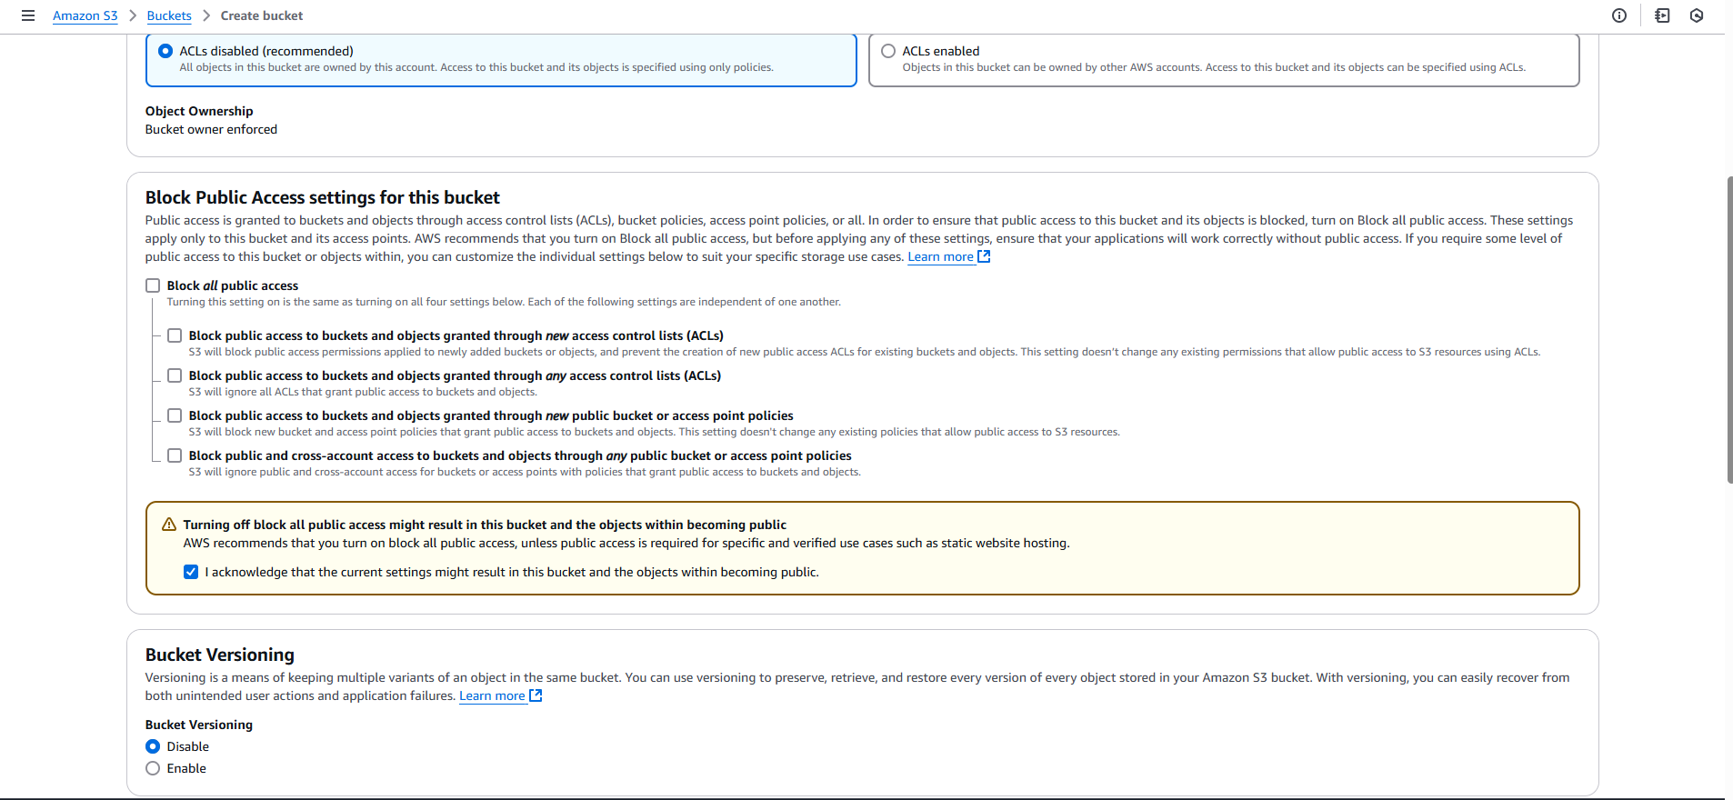

* Bucket has been created successfully.

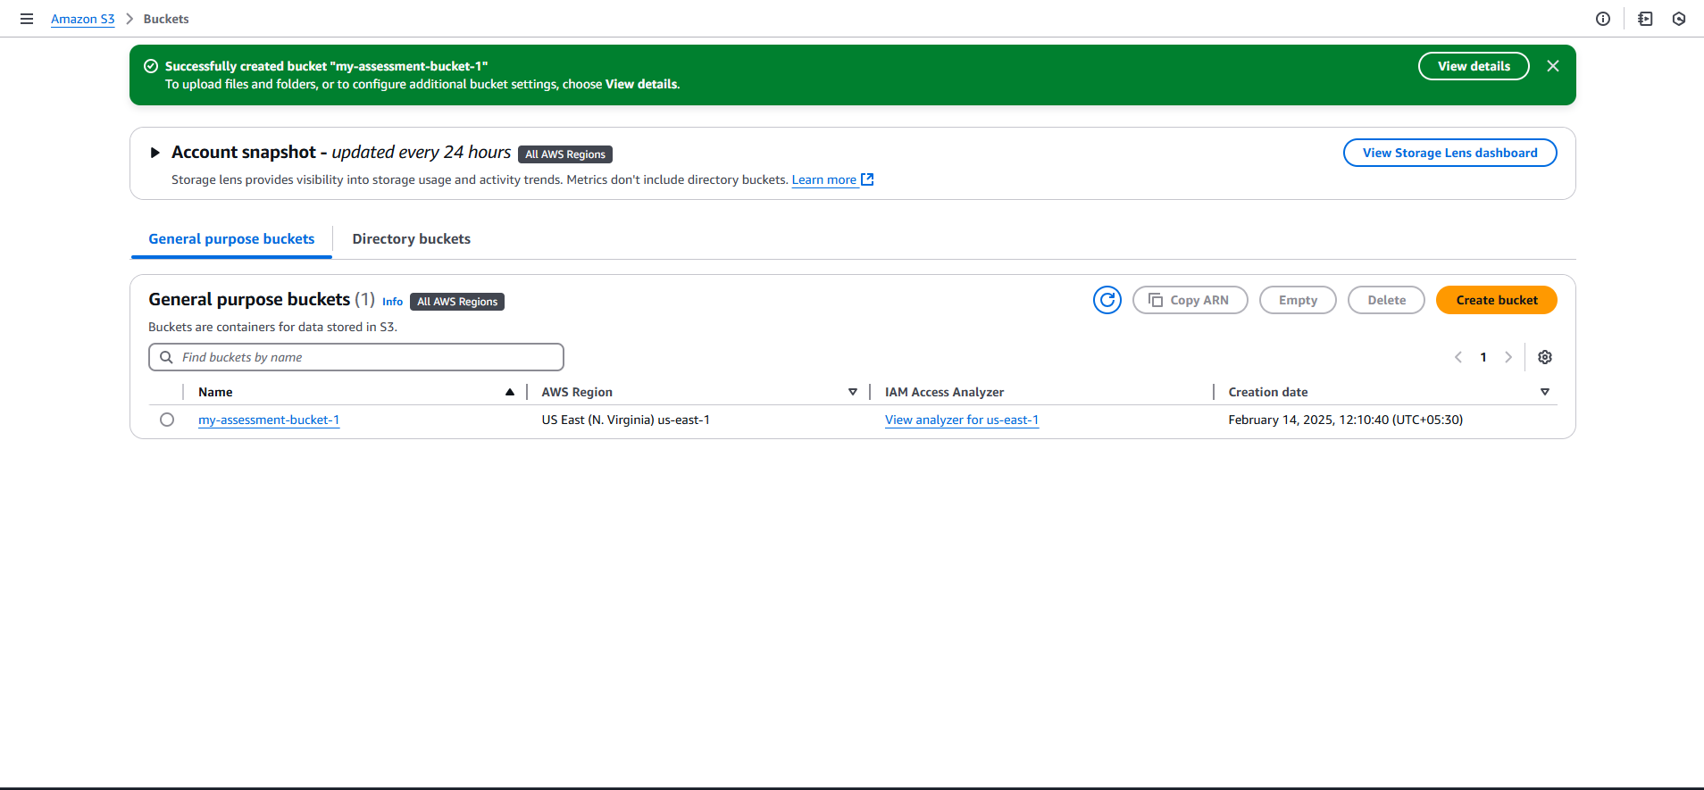

STEP 2: Uploaded the file in the bucket which has been created.

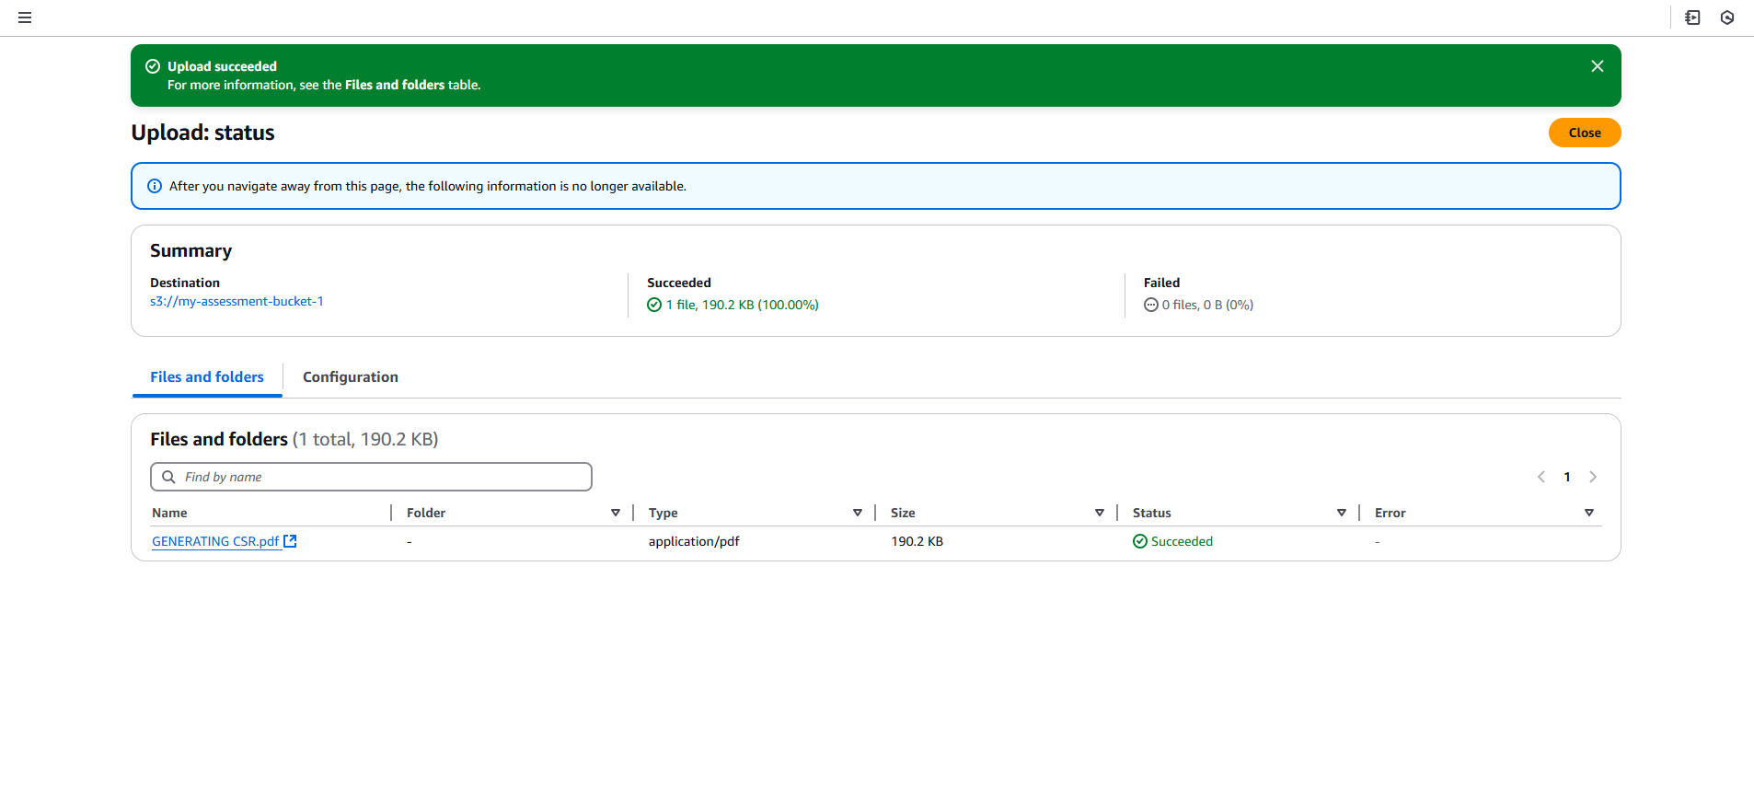

STEP 3: Create policy for the S3 Bucket.

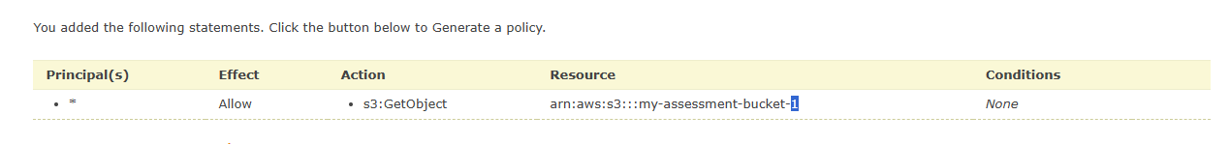

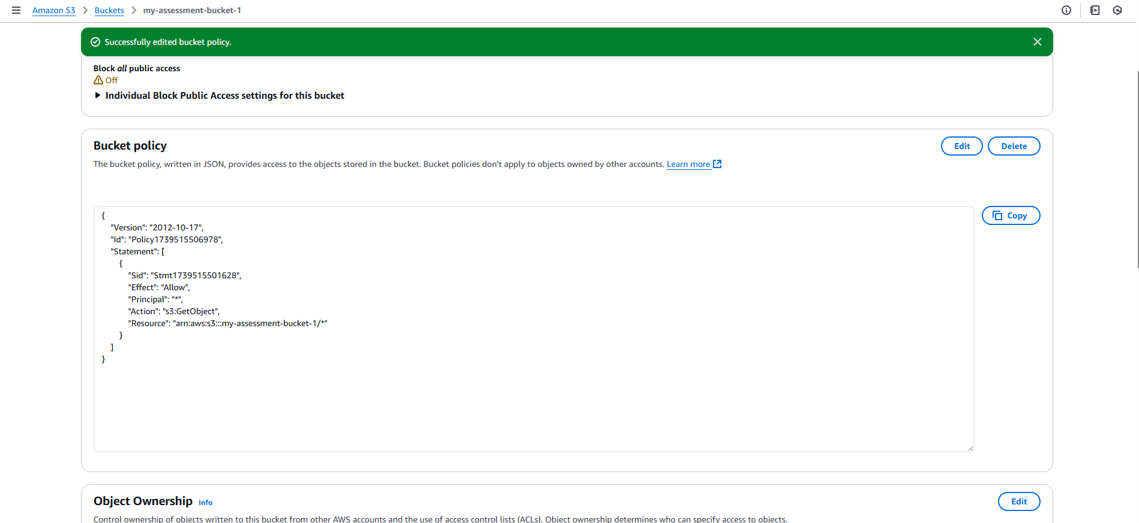

* Successfully added the bucket policy.

STEP 4: Check the public access: [Public Access URL](https://my-assessment-bucket-1.s3.us-east-1.amazonaws.com/GENERATING+CSR.pdf)

